ACSL
American Computer Science League
2013 - 2014

Contest #4

Classroom Division

6.
6. Data Structures
How many nodes have only one child in the binary search tree for
DENVERBRONCOS

7.
7. Data Structures
What would the next popped element be in the following queue?

PUSH(P), PUSH(I), PUSH(K), POP(X), POP(X), PUSH(E),
PUSH(S), PUSH(P), POP(X), POP(X), PUSH(E), POP(X), PUSH(A), PUSH(K)

8.
8. Digital Electronics What ordered triple(s) make the following circuit FALSE?
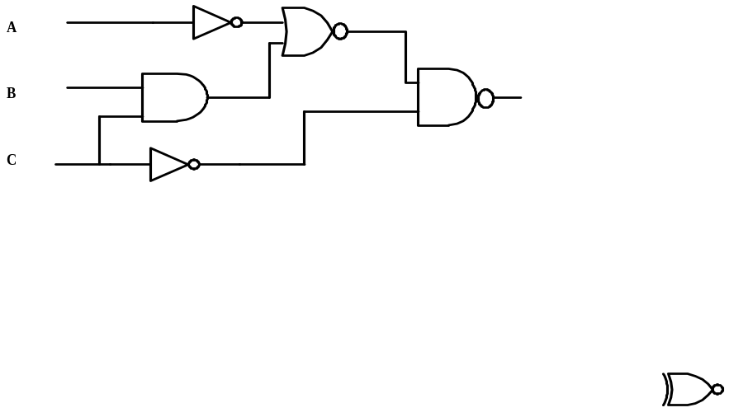

9. Digital Electronics Simplify the Boolean expression represented by the
circuit below.
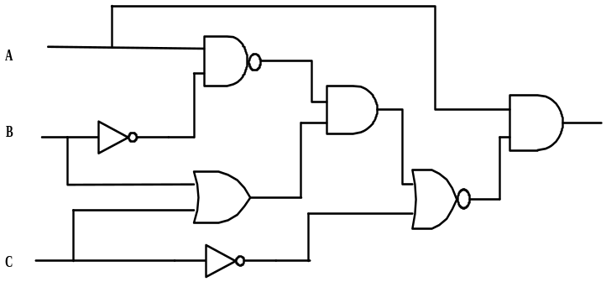
9.

10. LISP
Evaluate
(CAR (CDR (CDR ‘( 1 ( 2 ) ( 3 ( 4 ) ) ) ) ) )

10.

